VERSION
1

QUALITY MANAGEMENT

BASHUNDHARA PAPER MILLS LTD.

BBP DOCUMENT

“Quality Management”

Prepared By: Consultant Reviewed By: CTM(QM),BG

Document & Version Control
Department | Quality Control | Document Type | New
Title | BBP Document of QM | Document ID | QM_BBP_QM01/BPML/001
Start Date | 22 February 2016 | End date | 26 March 2016
Date | Description of change | Prepared By | Reviewed By | Version
18/02/2016 | Initial draft | Consultants | CTM | 1.0
16/03/2016 | Review | Consultants | CTM | 1.0
26/03/2016 | Final review | Consultants | BPO, CTM | 1.0

BBP Approval
Function | Name | Role | Signature & Date
Prepared By |  | MM/QM Consultant
Prepared By |  | MM/QM Consultant
Reviewed by |  | Team Lead
Reviewed by |  | CTM (Unit-1)
Reviewed by |  | CTM (Unit-2)
Reviewed by |  | CTM (Unit-3)
Approved By |  | Head of Project

Project Manager
Organization | Project Manager | Signature & Date

Contents
1 Introduction 6
2 Process Design and Mapping 7
2.1 Key Data Structure 7
2.1.1 Control Keys: 7
2.1.2 Keys for Certificate Processing: 8
2.1.3 Number ranges for Certificate receipt: 8
2.1.4 Inspector Qualification. 8
2.1.5 Control Indicators for Inspection Characteristic: 9
2.1.6 Work center/Quality Lab 9
2.2 Process Description 9
2.2.1 Functions of the QM Component 9
2.2.1 Functions of the QM – Information Flow 10
2.2.1 QUALITY PLANNING 11
2.2.2 QUALITY CONTROL 14
2.2.3 QUALITY CERTIFICATES 14
2.2.4 QUALITY NOTIFICATIONS 15
2.2.5 CONTROL IN LOGISTICS 15
2.2.6 Functional Scope 16
2.3 MODULE INTEGRATION 17
2.4 Process Flow Chart 18
2.5 Business Process Mapping 18
BUSINESS PROCESS MASTER LIST 18
2.6 Incoming Material Quality inspection 18
2.6.1 Purpose 18
2.6.2 Master Data 19
2.6.3 AS-IS of Incoming Material inspection of BPML 19
2.6.4 To-BE of Incoming inspection of BPML 21
2.7 In-Process Inspection 23
2.7.1 Purpose 23
2.7.2 Master Data 23
2.7.3 AS-IS of in process inspection Of BPML: 23
2.7.4 To-Be process of in process inspection Of BPML 25
2.8 GR from Production Inspection 27
2.8.1 Purpose 27
2.8.2 Master Data 27
2.8.3 AS-IS process of Final Production inspection of BPML. 27
2.8.4 TO-Be Process of Final Production inspection of BPML 29
2.9 Customer Complaints and Returns 31
2.9.1 Purpose 31
2.9.2 Master Data 31
2.9.3 AS-IS of Customer complain & Customer Return Process. 31
2.9.4 TO-BE of Customer Complain & Return Delivery. 33
2.10 Stock Transfer Inspection 34
2.10.1 Purpose 34
2.10.2 Master Data 34
2.10.3 AS-IS process of Transfer Posting inspection of BPML 34
2.10.4 TO-BE of transfer posting Quality inspection of BPML. 35
2.11 Audit Inspection 36
2.11.1 Purpose 36
2.11.2 Master Data 36
2.11.3 AS-IS of Audit Inspection of BPML. 36
2.11.4 TO-Be process of Audit Inspection of BPML. 37
2.12 General QM Functions 37
2.12.1 Purpose 37
2.12.2 Master Data 38
2.12.3 AS-IS of inspection Cost Tracking OF BPML. 38
2.12.4 TO-BE process of inspection Cost Tracking of BPML. 38
2.13 Miscellaneous Inspection 39
2.13.1 Purpose 39
2.13.2 Master Data 39
2.13.3 AS-IS process of Miscellaneous Inspection in BPML. 40
2.13.4 To-BE process of Miscellaneous Inspection of BPML. 40
2.14 Test Equipment calibration 41
2.14.1 Purpose 41
2.14.2 Master Data 41
2.14.3 AS-IS process of Calibration of BPML . 41
2.14.4 TO-BE of Calibration of BPML. 42
2.15 Sales Inspection/Outbound Inspection 42
2.15.1 Purpose 42
2.15.2 Master Data 43
2.15.3 AS-IS process of Outbound Inspection of BPML. 43
Applicable for Unit-1: 43
Applicable for Unit-3: 43
2.15.4 To-BE process of Out Bound inspection Of BPML. 45
3 MODULE INTEGRATION 45
3.1 Material Management 45
3.2 Production Planning 46
3.3 Sales and Distribution 46
3.4 Plant Maintenance 46
3.5 Controlling 46
3.6 Question and Answer 46
4 Gap Analysis 47
4.1 Gap Identified 47
4.2 Question & Answer 47
4.3 Fit Gap 47
5 Reports 47
5.1 Reports and evaluation transaction for Quality Planning 47
5.2 Reports and evaluation transaction for Quality Inspection 48
5.3 Reports and evaluation transaction for Test Equipment Management 50
6 User Role and Authorization 51
7 Process Improvement 51
8 Conclusion 51

Introduction

Bashundhara Paper Mills Limited is a pioneer among the private sector paper producers in the country. The enterprise, since its inception in 1993,has been helping the nation save huge amount of hard-earned foreign exchange by cutting dependence on imported paper products. Bashundhara Paper Mills has three manufacturing units. Units are as follows:

Bashundhara Paper Mills Limited Unit-1
Bashundhara Paper Mills Limited (Unit-1) was set up in 1995 as an import substitute paper manufacturing company with three paper machines mainly to meet the fast growing local demand for various categories of paper with an ultimate goal to reduce country’s dependence on imported paper and paper products as well as saving on hard earned foreign currency. Bashundhara Paper Mills Limited is an (ISO):9002 certified company which is producing a diversified range of high quality paper products, such as White Writing and Printing Paper, Colored Printing Paper, Offset Printing Paper, A4 Offset Paper, Local Cigarette / Bidi Paper, Brown Wrapper, Newsprint, Carbonless Paper, Sticker Paper, Cast Coated Paper, Exercise Books, Cement Paper and Poly Bags of multifarious use.

Bashundhara Paper Mills Limited Unit-2
Bashundhara Paper Mills Limited (Unit-2) was previously known as Bashundhara Newsprint & Duplex Board Industries Limited and was set up in 1996 as the second paper manufacturing unit of Bashundhara Group. The factory operates three modern plants in producing Newsprint, Duplex Board, Liner Paper and other paper products. The first line produces Duplex Boards used in the packaging industry. The second lines produces Newsprint for use as printing material by national dailies, weeklies and fortnightlies. The third plants makes Art Paper, Art Card, Matt Paper and Matt Card, FBB Board, etc. The unit has also installed the country’s largest De-inking facility which uses Waste Paper to manufacture recycled pulp for various newsprint and paper board application and manufacture.

Bashundhara Paper Mills Limited Unit-3
Unit-3 of Bashundhara Paper Mills Limited, previously known as Bashundhara Tissue Industries Limited, was set up in 1998 as the country’s first basic tissue manufacturing industry to cater to the growing demand and popularity of quality soft-tissue for different use within the country. Presently it operates five production plants. It is manufacturing a wide range of products including Facial Tissue, Toilet Tissue, Napkin/Serviettes, Kitchen Towel, Hand Towel/Industrial Wipes, Clinical Bed Sheets, etc. in both virgin and recycled grades. The unit also products A4 Paper, Glassine Paper, Sandwich Paper, Hard Tissue (both food grade and non-food grade). It further manufactures Hygiene Products such as Wet Tissue, Sanitary Napkin, Baby Diaper, Baby Wipes and Hand Gloves (both surgical and non-surgical). Products from this unit are exported to various countries of the world regularly and has gained a reputation for excellent quality and consistency.

Process Design and Mapping

Key Data Structure

Control Keys:
This key determines which conditions are valid for quality management in procurement. This key controls whether certificate requirement, invoice block active, Quality agreement requirement & Vendor Release Required for Regular Delivery
Sl No. | Control Keys | Description of control keys
1 | 0000 | No active functions, info message
2 | 0001 | Delivery Release
3 | 0002 | Delivery Release, Tech. Delivery Terms
4 | 0003 | Del.Release, Tech.DelTerms, QA Agreement
5 | 0004 | Del.Rel,TechDelT,QAAgreement,Certif.
6 | 0005 | Delivery Release, Certificate
7 | 0006 | Delivery Release, Documentation Required
8 | 0007 | Delivery Release, Invoice Block
9 | 8888 | Vendor Block Inactive
11 | 9999 | All functions active with error message

Keys for Certificate Processing:
This defines quality Certificate types for procurement & Delivery. A quality certificate includes:
- The use of certain manufacturing or work processes
- The execution of defined inspections on the basis of laws, norms, customer specifications or other agreements
- The existence of defect-free inspection results
Sl No. | Certificate Types | Description of Certificate Types
1 | E21 | Cert. of conformity "2.1" EN 10204
2 | E22 | Test certif. "2.2" EN 10204
3 | E23 | Works test certif. "2.3" EN 10204
4 | E31A | Insp. certificate "3.1.A" EN 10204
5 | E31B | Insp. certificate "3.1.B" EN 10204
6 | E32 | Inspection report "3.2" EN 10204

Number ranges for Certificate receipt:
No. | Range
01 | 000000000001- 099999999999

Inspector Qualification.
These inspector qualifications are defined at the client level and proposed at the level of the inspection characteristics or inspection methods in the task list.
Sl No. | Inspector Qualification | Description of Inspector Qualification
1 | BPIS1 | B.Sc./M.Sc. in Chemistry

Control Indicators for Inspection Characteristic:
This control keys for the attributes of Inspection characteristic. The control key is used to propose or predefine the control indicators for the master inspection characteristics and inspection plan characteristics.
Sl No. | Control keys | Description of control | Activity control
1 | BPML | Basundhara Paper mill control key. | Lowe specific Limit ,Upper specific Limit, Summarized result recording, Required Characteristic for result recording, Inspection scope fixed ,Record Measured Values , Print

Work center/Quality Lab
Sl No. | Work center | Description of work center/Quality Lab
1 | PAPER-01 | Quality lab of paper of Unit-1
2 | PAPER-02 | Quality lab of paper of Unit-2
3 | PAPER-03 | Quality lab of paper of Unit-3
4 | PPWB-01 | Quality lab of PP/Sack Bag of Unit-1
5 | DMPL-01 | Quality lab of DM plant of Unit-2

Process Description
The QM application component supports tasks associated with quality planning, quality inspection and quality control. In addition, it controls the creation of quality certificates and manages problems with the help of quality notifications.

2.2.1 Functions of the QM Component

The QM component fulfills the following functions:
- Quality Planning
  - Manages master data for quality planning
  - Supports inspection planning
- Quality Inspection
  - Processes Inspection Lots, selects Inspection Plans, calculates samples, for sampling and inspection
  - Provides inspection results in the form of characteristic values, defect data, and texts
  - Handles the usage decision, inventory postings, and follow-up actions

- Quality Control
  - Allows sample determination on the basis of the sampling procedure, Inspection Lot or by inspection characteristic
  - Determines quality scores for Inspection Lots
  - Provides statistical process control, quality control charts, and process capability indices
  - Provides the QM Information System with Inspection Lot quality scores, inspection results, and quality notifications
  - Supports flexible reporting with the help of user-defined reports
- Quality notifications relating to internal and external problems
  - Records the nature of the problem
  - Processes corrective tasks and monitors the response time, as well as links, the person responsible for carrying out the tasks and stores original documents
- Test equipment management
  - Supports calibration planning for test equipment that is to be inspected/calibrated.
  - Controls calibration inspections of test equipment
  - Makes the usage decision

Functions of the QM – Information Flow
Master Data
QM Transaction Flow
1. Inspection Lot Creation
(Contains Material Code,
Qty, Inspection Plan,
Sample Size)
Goods Receipt
Sales
Production
Storage
Stock Transfer
Manual lot
Etc

2. Results Recording
3. Usage Decision
Material Master
Inspection Plan
Codes
Defects Recording
Sampling Procedure
Selected Sets
Notifications
MIC
SAP Transactions Flow
-------Evaluation of Results, Defects, Stocks, Vendors etc------

QUALITY PLANNING

Quality Planning – Basic Data

In the basic data (master data), information is stored, that is used often. In QM, the following master records are available:
- Material Master QM View
- Inspection Method
- Master Inspection Characteristic
- Inspection Plan
- Catalog / Selected Set
- Sampling Procedure
- Sampling Scheme

Quality Planning – Inspection Planning

Inspection planning functions are used to define inspection criteria (for example, material to be inspected, how the inspection is to take place, characteristics to be inspected, required test equipment, work center and inspection specifications).
The R/3 System contains the following inspection planning options:
•We can use task lists (Inspection Plans, routings, rate routings and maintenance task lists) to define inspection characteristics, assignment to inspection operations and the test equipment to be used. This enables us to inspect materials in quality inspection.
•The Material Specification allows us to carryout simple inspection planning at client level.

QUALITY INSPECTION

Quality Inspection component is used to determine whether manufactured product consistently meets defined quality requirements. In a quality inspection, we inspect a material or product, using inspection specifications that have been predefined in the Inspection planning component. Although the inspection results only document the current quality of a material or product, this information is also useful for quality control (for example, to optimize future processes).
Quality inspection covers the following important functions:
• Inspection lot creation
• Results recording
• Defects recording
• Inspection lot completion (Usage Decision)

Quality Inspection - Inspection lot creation

In the Quality Management (QM) component, we process quality inspections on the basis of Inspection Lots. If we want to inspect a specific quantity of a material or a piece of equipment, an Inspection Lot must be created in the system. Once an Inspection Lot has been created, we can inspect the goods, record the inspection results or defects, and complete the inspection with a usage decision.
The system uses the Inspection Lot to record, process, and manage information for a quality inspection. This information includes Inspection processing data such as:
• Inspection lot origin
• Inspection date
• Processing status of Inspection Lot
• Account assignment information for cost settlement
• Inspection specifications (for example, the task list or Material Specification according to which the goods in the Inspection Lot will be inspected)
• Inspection results
• Recorded characteristic values
• Recorded defects
• Usage decision (a decision that specifies whether the goods in the inspection have been accepted or rejected)

An Inspection Lot can be created manually by the user or automatically by the system.
Once an Inspection Lot has been created, an Inspection Plan is usually assigned to it. The system can assign an Inspection Plan automatically or we can assign one manually.

Quality Inspection – Result Recording

In the Results Recording component, we record and process results for inspection characteristics. The Inspection Lot is the reference object in results recording.
The recorded inspection results document the quality of the inspected product and provide the basis for creating batch specifications and inspection certificates. We can use the recorded result data to make evaluations for quality control purposes.
This function includes a work list for recording inspection results for all objects that allow results recording (Inspection Lots, partial lots, Inspection Points in production or goods receipt, physical samples, equipment, and functional locations).
After Inspection Lot selection, the first operation with characteristics to be processed appears automatically. The corresponding characteristic overview screen is displayed to record results. (If we select a characteristic for results recording, the characteristic single screen appears.)
The characteristic overview screen displays an overview of all the characteristics in an operation. On the characteristic overview screen, we can confirm the following inspection results depending on the recording view:
• Summarized values and single values
• Summarized values

We can organize the view selection according to your needs using user settings.

Quality Inspection – Defects Recording

When we process an Inspection Lot, we can record the results for the inspection in the form of characteristic values or defects. A defect is any property or attribute of a material, product, or process that does not meet the characteristic specifications. We record the defects with the help of predefined defect codes maintained in the inspection catalogs.
Defects records can serve as a valuable source of information for quality control. They allow us to improve quality or optimize processes, while reducing costs and increasing productivity.

We can analyze defects and their causes on the basis of defect records. We can determine what corrective action is necessary to eliminate the defect cause and prevent them from recurring. Defect records can be created in the system in the following ways :
• The system can create the defects record automatically during results recording.
• We can create the defects records manually using the defects recording function.

Quality Inspection – Inspection Lot Completion

Once inspection results have been recorded for an Inspection Lot and the inspection is finished, we must reach a decision about the usage of the inspected material. The Inspection Lot Completion (QM-IM-UD) component provides us with the functions to:
• Complete an inspection (inspection completion)
• Make the usage decision for an Inspection Lot
• Make stock postings for Inspection Lots that were created as a result of goods movements (for example, to unrestricted-use stock, blocked stock, and scrap)
when we make a usage decision for an Inspection Lot, the system also:
• Calculates a quality score for the Inspection Lot
• Updates the QM Information System with statistical data
• Triggers automatic follow-up actions (optional)

Usage decision

When we make the usage decision, we decide whether to accept or reject the goods in the Inspection Lot based on the results of the inspection. While we are in the transaction for the usage decision, we can also:
• Record defects
• Activate quality notifications
• Confirm activities for QM orders
• Make stock postings
• Once we have made the usage decision, the inspection is completed.
Usage decision is irreversible once completed.

QUALITY CONTROL

Active quality control ensures the constant quality of the processes and products.
We use quality control to:

• Usage of control charts to control the characteristic values
• Update of the vendor evaluation for the procurement process

Quality Control – Statistical Process Control

Statistical process control (SPC) is used to monitor, control, and improve processes. Master data to be setup according to SPC requirements.

QUALITY CERTIFICATES

A quality certificate certifies the quality of goods. The chemical or physical properties of goods can be recorded as:
• Inspection results
• Characteristics for the batch

A customer may have specific demands for quality, which may take the form of customer-specific specifications (specification limits), or lead to additional quality inspections.
In addition to customer-specific certificates in which the contents and format is tailored to the customer requirements throughABAP, there are also general certificates that are suitable for use.

QUALITY NOTIFICATIONS

This component contains functions for recording and processing different types of problems (for example, problems resulting from poor-quality goods or services). We can use the notifications to analyze the recorded defects and monitor the correction of these problems. In particular, the notifications can help us process internal or external problems such as:
- Complaints against vendors
- Internal problems
- Complaint from customer
- Other user-specific problems

As an extremely flexible system, we can also use this component to process and manage information of a positive nature.

CONTROL IN LOGISTICS

Control In Logistics – QM In Procurement

This component controls the integration of the QM application component in the logistical processes. QM is integrated in the master data and processes of:
• Materials management (procurement, inventory management, materials planning)
• Production (work scheduling, production control)
• Sales and distribution (delivery, certificate creation)

This component contains functions that allow us to integrate the tasks of Quality Management with the procurement processes.
Using the functions of the QM in Procurement component, we can:
• Manage quality-related information for materials and vendorsin quality info records
• Release or block vendors
• Monitor the QM systems of vendors
• Supply quality documents with requests for quotations and purchase orders
• Evaluate vendors on the basis of quality
• Certify vendors that have QM systems implemented, to reduce the inspection requirement
• Manage and release supply relationships
• Request that quality certificates be submitted with the delivered goods and monitor the receipt of these certificates
• Inspect vendor goods upon receipt (goods receipt inspections)
• Manage the posted goods in inspection stock
• Block the payment of invoices until the goods have been inspected and accepted
• Inspect goods that have been externally processed when they are returned in a goods receipt

Control In Logistics – QM In Production

This component contains functions, which allows carrying out several individual inspections at different intervals during production or as a result of certain events. With the component QM in Production, we can process inspections during a production operation (while manufacturing discrete/repetitive parts). We can monitor the production process continuously with respect to the inspection characteristics.
Using Inspection Points for an inspection during production, we can:
- Inspect materials at regular intervals
- Quantity-based intervals (for example, an Inspection Point)
- Freely -defined intervals (for example, an Inspection Point each time a tool change occurs)
- Record inspection results for each Inspection Point (for example, for each container or work shift) and valuate each Inspection Point with a "usage decision"
- Assign a produced quantity to each Inspection Point and allocate the Inspection Point quantities to partial lots.

When a production order is released, the system creates an Inspection Lot record (For Discrete) to manage the inspection specifications and inspection results for all operations.
Through the integration of the batch management functions, the system can transfer the inspection results for a partial lot to the batch and these results can subsequently be used to classify the batch. As a result, batches can be selected on the basis of inspection results in Sales and Distribution (SD). The inspection results can also be used to create quality certificates.

With production lots with Inspection Point processing, the system transfers the results to the batch classification when we record results for the Inspection Point and not when the usage decision is made.

Control In Logistics – QM In Sales And Distribution

The Quality Management (QM) component supports Sales and Distribution (SD) by processing quality inspections and creating quality certificates for deliveries and processing customer returns.

Functional Scope

- Quality Planning
  - Basic Data
    - Inspection Methods
    - Master Inspection Characteristics
    - Catalogs
    - Sampling Procedure
    - Sampling Scheme
    - Sample Drawing Procedure
  - Inspection Planning

- Quality Inspection
  - Inspection Lot Creation
  - Results Recording
  - Defects Recording
  - Inspection Lot Completion
  - Sample Management
- Quality Control
  - Statistical Process Control
- Quality Certificates
- Quality Notifications
  - Notification Processing
- Test Equipment Management
  - Test Equipment Management
  - Processing a Calibration Inspection
- Control in Logistics
  - QM in Procurement
  - QM in Production
  - QM in Sales And Distribution
- General Functions
  - Quality-Related Costs

MODULE INTEGRATION
The Quality Management module is fully integrated with other modules of SAP R/3. The continuous exchange of information with other application areas in the R/3 System ensures a real time database.
Considering the specific requirements of the organization, the SAP QM module could be integrated with other modules.
The broad level integration areas with SAP QM module are,
5.1 MATERIALS MANAGEMENT
- Material Master
- Vendor evaluation
- Processing goods receipt inspections
- Role in invoice processing for quality nonconforming material supply
5.2 SALES & DISTRIBUTION
- Sales Inspection
- Customer Complaints
5.3 PRODUCTION PLANNING AND CONTROL
- In process Inspection
- After-Production Inspection
5.4 PLANT MAINTENANCE
- Calibration Inspection
5.5 CONTROLLING
- Cost of Quality

Process Flow Chart

Business Process Mapping

BUSINESS PROCESS MASTER LIST

Incoming Material Quality inspection

This covers all the Inspections and related Activities pertaining to Incoming materials.

When a material (Part Nos/Tools/Gauges etc) is received Inspection Lot (with Origin 01 – Goods Receipt) gets created for the GR quantity. The Inspection Lot will have Inspection Plan and Sample size. The Lots Inspection Results will be recorded in the “Results Recording”, and Disposition details to be entered in the “Usage Decision”.

Purpose

All the functionalities related to Incoming Inspection of Materials.
The process describes

    - ”Inspection lot” creation during Goods Receipt.
    - Automatic posting to Quality Inspection stock.
    - “Result Recording” for the lot.
    - “Defect Recording” for the non-conformance noticed and information to the concerned through
    - ”Notification” (Corrective action process) for non-conformance
    - “Usage Decision” for the lot
    - “Quality Score” (Automatic) to vendor for usage decision of lot.
    - Stock Posting from Quality Inspection to Unrestricted stock.
    - Cost of Quality through “QM order” processing.

Master Data

    - Inspection Plan
    - WorkCenter
    - Master Inspection Characteristic
    - Inspection Method
    - Catalog
    - Selected Set
    - Sampling Scheme
    - Sampling Procedure
    - Q Info Record

AS-IS of Incoming Material inspection of BPML
- Incoming Material includes Raw Material - Fibrous raw Material like Pulp(softwood Pulp(NBKP), Hardwood Pulp(LBKP), Waste paper like ONP (Old News Paper), OINP (Over- Issued News Paper),SWL (Sorted White Ledger), MWL (Manifold White Ledger), OMG (Old Magazine), WBN (White Blank News), SOP (Sorted Office Paper), OCC (Old Corrugated Containers), NDLKC (New Double Lined Kraft Corrugated Cuttings), BBC (Box Board Cuttings), HWS (Hard White Shavings), HWEC (Hard White Envelope Cuttings)etc. , Chemical like Aluminum Sulphate (Al2SO4), Calcium Carbonate , Starch Powder (Native),Sodium Silicate (55 ºBe) , Caustic Soda ,Packaging Material , spares & consumables.
- Store & QC department jointly inspecting material physically & Checking challan& invoice during vendor delivery.
- During physical checking, if they are finding some problem in delivery, immediately rejecting this delivery otherwise store department provisionally accepting this delivery.
- QC department collects samples & conditioning in Lab for testing.
- QC departments Records result of testing of Specific Characteristic & confirms the consuming department to take Usage decision.
- If testing result is out of specification, then Head of consuming Department is taking decision of acceptance .in case of local vendor, material returns possible but in case of foreign material, Management is taking decision.
- Some cases after inspecting material, if material is under expectation of quality standard. then it must degraded to other material.
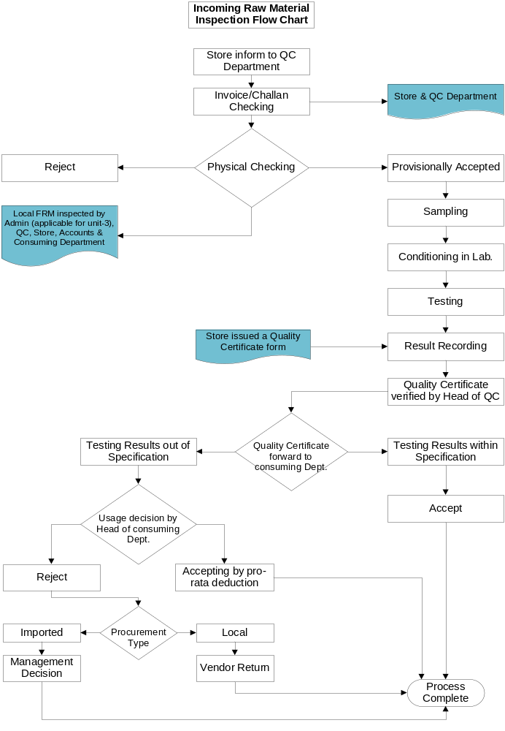

To-BE of Incoming inspection of BPML

- After receiving the materials from the vendor, Stores will prepare the GRN (Goods Receipt Note) in the system.
- As soon as the GR is prepared system will generate Inspection Lot automatically. Stock will be posted to “Quality Inspection” stock.
- Through the transaction “QA32” QC Dept. will be intimated about the creation of new Inspection Lot.
- For every GR, system will automatically calculate the sample size as per the sampling procedure. Through transaction “QA02” QC can check the sample size, batch no. etc. Inspection Plan gets attached automatically to the Lot
- QC shall analyze the samples as per the in-house specifications (Dimensional and Material Analysis). QC personnel will record the results through the transaction “QE51N/QE01”
- System will derive the calculation automatically for the “Calculated Characteristics” based on the values of dependent characteristics, if any, as per the Inspection Plan.
- Depending on the values of the results, system will take automatic decision of “Accepted or Rejected” for the Values entered (manual valuation also possible here, depending on the settings).
- After recording the results by QC, system can generate the copy of “Inspection Report” (if required) after giving usage decision for the lot.
- In case of “Acceptance” can generate an “Inspection Report” from the system. Transfer posting will be done automatically from the system and the stock will be moved from “Quality Inspection” stock to “Unrestricted” stock.
- In case of “Rejection”, system will prompt for recording the defects and maintaining text. It will also generate a notification automatically and can be sent to “Blocked stock”.
- In case of Non-conformity, manually create the notification. This Notification to be processed and closed later.
- In case of material which will be degraded to lower quality FRM, during UD, it will be converted to New Material.

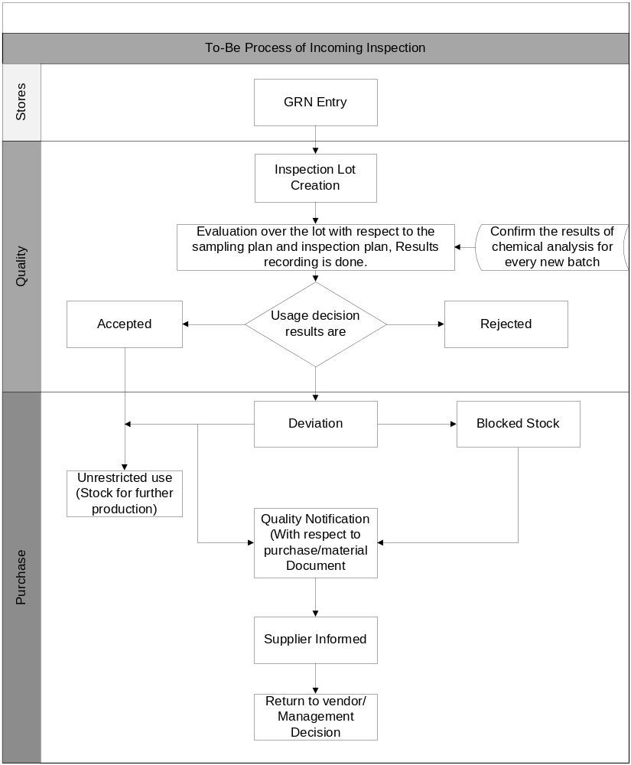

In-Process Inspection

When Production Orders are released for processing, QM can automatically create Inspection Lots in preparation for the quality inspections. The order types that can trigger quality inspections include:
- Production orders
Production orders are typically used for the production of goods in the discrete manufacturing applications. When these orders are released, orders can trigger Inspections during Production.
- During production, it may be necessary to carry out a several individual inspections at different intervals. Inspections carried during a production operation at regular intervals like below....
- Time-based intervals (for example, for every hour )
- Quantity-based intervals (for example, after producing certain Quantity)
- Freely-defined intervals (for example, each time a tool change occurs)

Purpose

To carryout Inspection during the execution of Production in reference to a Production Order.

Master Data

    - Routing
    - WorkCenter
    - Master Inspection Characteristic
    - Inspection Method
    - Catalog
    - Selected Set
    - Sampling Scheme
    - Sampling Procedure
    - Production Resources/Tools

AS-IS of in process inspection Of BPML:
- In BPML, There are some pre-selected sampling points for producing different types of products. Samples are taken from those sampling points in predefined time intervals by assigned tester to test in the laboratory during production continuation.
- Some specific sampling points are Pulper, Dump/Pulper Chest, Pre Floatation Cell, Pre Floatation Cell, Reject Floatation Cell, Washer 1, Washer 2, Washer 3, Disperser, Bleaching Tower-1, Bleaching Tower-2, High Density Tower, Beater, Beater Chest, Refiner Chest, Blending/Mixing Chest-1, Holding/Mixing Chest-2, Machine Chest, Level Box etc.
- Some specific testing parameters like pH, Consistency, °SR, Brightness are measured by Quality department.
- Test results are inputted into the result sheet and informed concern production personnel time to time for further necessary corrective measure.

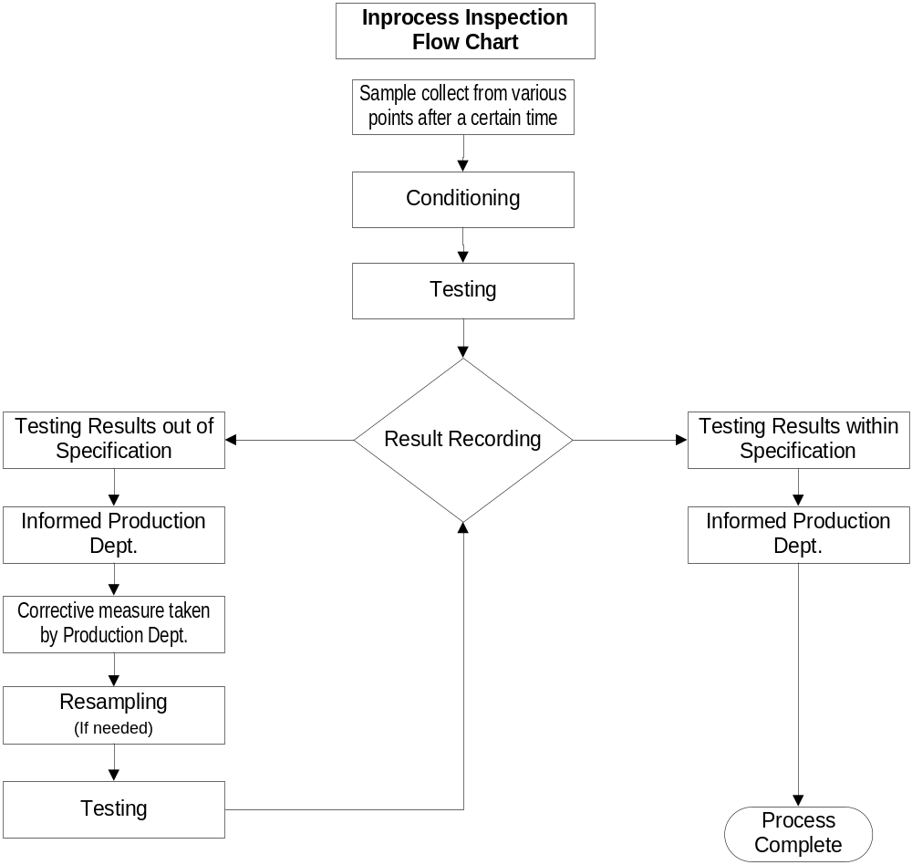

To-Be process of in process inspection Of BPML

- For each material (Intermediate), at least one Routing will be maintained.
- For all the intermediate/FG material an inspection type 03 will be maintained in the QM view of Material Master, which will lead to automatic creation of Inspection Lot when the Production order is released.
- Routing will have the details of various inspection operations to be performed on different time/Qty intervals.
- Production Personnel will create a Production order.
- After releasing the Production order system will automatically create an Inspection Lot, the number of which can be seen in production order itself.
- QC personnel will perform all the tests as per the Routing and record the results for various characteristics for different Inspection Points.
- Inspection points are maintained in Routing.
- If the results are found within the tolerance range then characteristics will be accepted.
- If the results are found non-conforming then manually enter defects and problem recording and generate a notification
- After result recording. Usage decision is made. This lot is non-stock relevant.

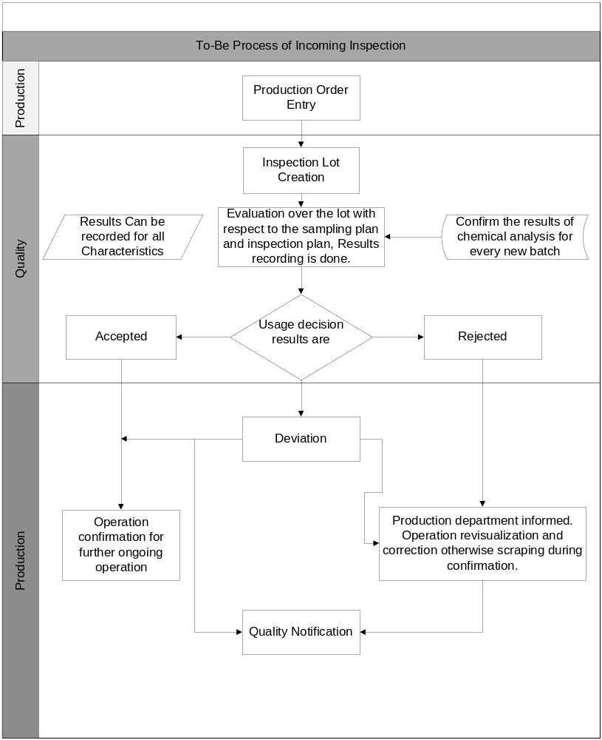

GR from Production Inspection

Inspection of production confirmed quantity.

Purpose

Inspection of the completed lots from Production Confirmation. This functionality is used when you need to do a quality inspection in a product after production process. It is an integration between PP (Production Planning) and QM (Quality Management).

Master Data
    - Inspection Plan
    - Material Specification
    - WorkCenter
    - Master Inspection Characteristic
    - Inspection Method
    - Catalog
    - Selected Set
    - Sampling Scheme
    - Sampling Procedure

AS-IS process of Final Production inspection of BPML.

- BPML plant inspecting Mother Roll, Baby Roll & Cut sheet, facial tissue, Napkin as finished product.
- Quality department initially checking Finished goods physically, if it is physically accepted, it is going for sampling process for collecting sample.
- After testing, Quality department records the result. If QC Passed, it will be shifted to finish store otherwise it will be degraded or re-pulped.

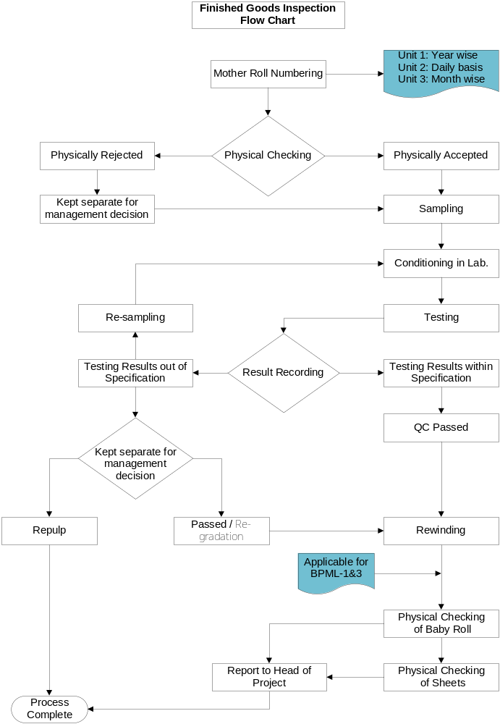

TO-Be Process of Final Production inspection of BPML

- After the Production, Production Personnel will do “Production Confirmation”.
- After the goods receipt of production, the Inspection Lotwill be generated automatically. Material stock will be placed into quality inspection stock.
- Sample calculation will be carried out automatically as per the sampling plan defined in the Inspection Plan.
- QC Personnel will carry out the inspection/tests & Record the result for the Inspection Lot using transaction QE51N/QE01/QA32 in Quality Management.
- If the result of any characteristics is found out of tolerance range, then system will automatically prompt for recording defects & subsequently generate a notification.
- If the material is found OK, then QC personnel/Consuming departmentwill take Usage decision and the materials will be posted to the unrestricted stock type.
- Results of Goods Receipt
- Material document will be created which keeps track of the material movement.
- Inspection Lot will be created for batch for which GR will be posted
- The stock of finished material is updated. Since Inspection Lot will be created, the material will be posted to the quality inspection stock type.
- In case of any deviation during the testing, create a notification manually

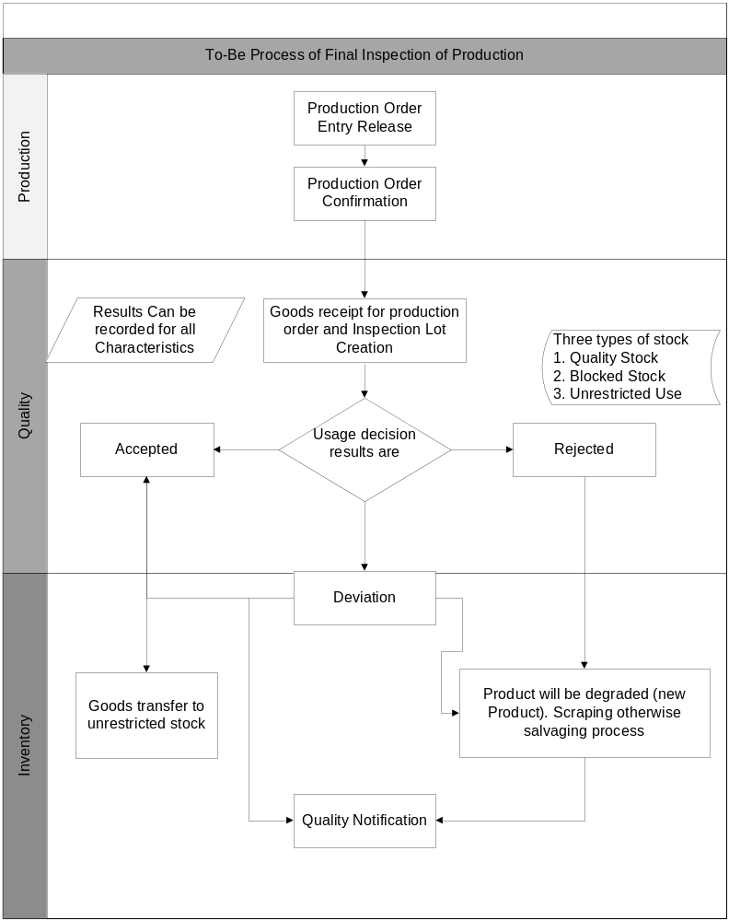

Customer Complaints and Returns

A customer complaint is a notification type (S1/S3/Q1) that deals with a problem involving poor-quality goods delivered to a customer.

Purpose
We can use a notification for a customer complaint to record and process a problem that is reported by a customer.

Master Data

    - Inspection Plan
    - Material Specification
    - WorkCenter
    - Master Inspection Characteristic
    - Inspection Method
    - Catalog
    - Selected Set
    - Sampling Scheme
    - Sampling Procedure

AS-IS of Customer complain & Customer Return Process.

- Customer complaints come to factory site through Sales, and Product & Compliance department. Factory management forms an inspection team to handle the complaint.
- After getting any customer complain, Team responsibility are to analyze the complaint. Request for additional information, if needed.
- Visit customer site for Visual Inspection, if necessary.
- If Requirement, Then Quality department is collecting sample for testing purposes.
- QC check report submitted to inspection Team as well as Head of the Project.
- If product is Ok, then complain is rejected otherwise complain sustained & replacement or adjustment is done for this delivery.
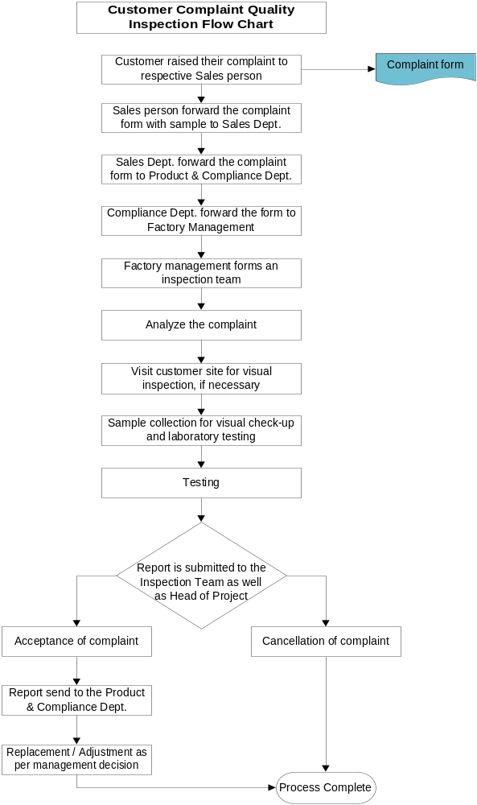

TO-BE of Customer Complain & Return Delivery.

- Notification will be created by the Receiver of the Complaint on receipt of the complaints (Line/Bulk /Warranty complaint) from the Customer. The type of Notification will be Q1
- Notification will have the details of Sale order/Delivery the customer, material, Quantity, date of dispatch, Details of complaints and date of complaint receipt
- Enter the details of the analysis and investigation in the “customer complaint report” of the notification in the long text and complete the corresponding tasks.
- The same Notification forwarded for communication to the customer.
- The Notification is closed after Completing All the tasks.
- If there are any pending jobs/tasks in the complaint, a list of pending jobs can be generated and mailed for further follow-up.

Customer Returns:
- After receiving the material (Bulk / Warranty) from the customer, commercial personnel prepares the sales returns document with reference to the sales order against which the materials were delivered.
- System will automatically create an Inspection Lot for the sales return and keep the stock in the Quality Inspection. An inspection type “06” should be maintained in the Material Master.
- After assigning the task list, system will automatically calculate the sample size.
- QC Personnel will perform all the tests and analysis and record the results in the result recording using transaction “QE51N”.
- If the material is found not OK, A Notification can be created for Scraping.!!!!

Customer Return process at Customer site:
  - Some Cases, BPML Quality Department is collecting sample from customer site.
  - If Quality department want to record the result in SAP system they have to create Inspection Lot manually in SAP system through QA01 giving 06 as inspection Point (for that 89 inspection type will be setoff in MMR)
  - QC Personnel will perform all the tests and analysis and record the results in the result recording using transaction “QE51N”.
  - Result List will be taken as Printout to show the Management for Replacement/Adjustment or Cancellation of complain.

Stock Transfer Inspection

This process describes how the system creates an Inspection Lot automatically for a stock transfer (Movement of material within/between plants).

Purpose

In a stock transfer, a material is moved from:
- One storage location to another within the same plant
- One storage location in a plant to another storage location in a second plant
- One Stock Type to Another Stock Type (UnR -> QI Stock)
When a stock transfer is posted for a material for which QM is active, the system creates an Inspection Lot that is stock relevant. The goods are posted to inspection stock for the duration of the quality inspection.

Master Data

    - Inspection Plan
    - Material Specification
    - WorkCenter
    - Master Inspection Characteristic
    - Inspection Method
    - Catalog
    - Selected Set
    - Sampling Scheme
    - Sampling Procedure

AS-IS process of Transfer Posting inspection of BPML

- Some cases BPML, doing Transfer posting of Raw materials, spares parts & finished product etc.(Loan case)
- In this case, if BPML wants to do QC during transfer Posting. Then Quality department can do result recording etc.

TO-BE of transfer posting Quality inspection of BPML.

- For each material (Raw Material/Intermediate/Finished Goods), one Inspection Plan for Stock Transfer will be maintained.
- For all the intermediate/FG material an inspection type 08 will be maintained in the QM view of Material Master,
- Inspection Lot to be created automatically during Stock Transfer for the transfer qty.
- Inspection Plan will have the details of various inspection operations to be performed.
- QC personnel will perform all the tests as per the Inspection Plan (Inspection instruction) and record the results for various characteristics.
- If the results are found within the tolerance range then characteristics will be accepted.
- If the results are found non-conformingthen system will prompt for defects and problem recording and automatically generate a notification
- After recording the results by QC, system can generate the copy of “Inspection Report”.
- In case of “Acceptance” transfer posting will be done automatically from the system and the stock will be moved from “Quality Inspection” stock to “Unrestricted” stock.
- In case of “Rejection”, enter defects and maintaining text. Create a notification and will be sent to “Blocked stock”.
- In case of Non-conformity found Defects Recording will Pop-up in the RR screen, and create a Notification.
- This Notification to be processed and closed later.

Audit Inspection

This process describes how the Audits can be carried-out with Inspection Lot.

Purpose

For the purpose of Audits like Product Auditetc, an Inspection Lot has to be created for RR and UD. This stock is non-stock relevant.

Master Data

    - Inspection Plan
    - Material Specification
    - WorkCenter
    - Master Inspection Characteristic
    - Inspection Method
    - Catalog
    - Selected Set
    - Sampling Scheme
    - Sampling Procedure

AS-IS of Audit Inspection of BPML.

- Comprehensive Master Data maintenance.
- Inspection Plan Management – manages all the Parameters required for inspection activity
- Non-Conformity Processing standardized across BPML thro Notifications
- Internal Documentation of the events (like task completion, entry of comments etc) handling by Quality Notifications.
- Extensive defect analysis and reporting with catalog management.
- Efficient tool for effective monitoring of tasks and corrective actions.
- The Quality Management Information System provides information at multi levels, which may be used in monitoring, controlling and planning business operations.

TO-Be process of Audit Inspection of BPML.

- For all the intermediate/FG material to be audited an inspection type 07 will be maintained in the QM view of Material Master,
- Inspection Lot to be created manually in QA01.
- Inspection Plan will have the details of various inspection operations (Audit) to be performed.
- QC personnel will perform all the Audit tasks as per the Inspection Plan (Inspection instruction) and record the results for various characteristics.
- If the results are found within the tolerance range then characteristics will be accepted.
- If the results are found non-conforming then system will prompt for defects and problem recording and automatically generate a notification (Discrepancy Report).
- After recording the results by QC, system can generate the copy of “Inspection Report” (Audit Report).
- Usage decision to be given to this lot for completion of the Audit. This Lot is non-stock relevant.
- In case of Non-conformity, we can put the stocks in the Blocked stock/Quality inspection stock during the Notification Processing.
- This Notification to be processed and closed later.

General QM Functions

Here we can bring in some special QM functionalities, which are common for all inspection Types to address specific BPML requirements.

Purpose

This Process covers the Special QM functionalities like:
- Cost of Quality
- Control of Non-conformance
- SPC etc.

Master Data

    - Inspection Plan
    - Material Specification
    - WorkCenter
    - Cost center
    - Master Inspection Characteristic
    - Inspection Method
    - Catalog
    - Selected Set
    - Sampling Scheme
    - Sampling Procedure

AS-IS of inspection Cost Tracking OF BPML.

- Cost of Quality is captured through Q.M Orders
- Dynamic SPC calculations in the RR stage.
- Comprehensive Master data maintenance.
- Non-Conformity Processing standardized across BFW thro Notifications
- Internal Documentation of the events (like task completion, entry of comments etc) handling by Quality Notifications.
- Extensive defect analysis and reporting with catalog management.
- Efficient tool for effective monitoring of tasks and corrective actions.
- The Quality Management Information System provides information at multi levels, which may be used in monitoring, controlling and planning business operations.

TO-BE process of inspection Cost Tracking of BPML.

Cost of quality:
Quality-related costs are the costs that are incurred by a company for planning and assuring the quality of a product or service, based on predefined quality requirements. These costs cover a wide range of expenses relating to the tasks of quality assurance. In the Quality Management (QM) application component there are the following quality-related costs:
- Appraisal costs (for Inspection Lots)
These costs are associated with inspection processing activities (for example, labour, material and equipment costs for inspections).
There will be a QM order for the lots for which Inspection Costs to be captured. In the RR and in UD should enter the confirmation values for the Activities.

Miscellaneous Inspection

This Covers the Inspections that are not covered in the standard Inspection Types.

Purpose
For the purposes like First-Off , last off , layout Inspection , functional testing etc., an Inspection Lot has to be created for RR and UD. This lot is non-stock relevant.

Master Data

    - Inspection Plan
    - Material Specification
    - WorkCenter
    - Master Inspection Characteristic
    - Inspection Method
    - Catalog
    - Selected Set
    - Sampling Scheme
    - Sampling Procedure
    - Production Resources/Tools

AS-IS process of Miscellaneous Inspection in BPML.

- Sometimes BPML is doing water quality test of Boiler water, ETP & river water etc.
- Comprehensive Master Data maintenance.
- Inspection Plan Management – manages all the Parameters required for inspection activity Material code-Plant wise
- Non-Conformity Processing uniformed across BPML thro Notifications
- Internal Documentation of the events (like task completion, entry of comments etc) handling by Quality Notifications.
- Extensive defect analysis and reporting with catalog management.
- Efficient tool for effective monitoring of tasks and corrective actions.
- The Quality Management Information System provides information at multi levels, which may be used in monitoring, controlling and planning business operations.

To-BE process of Miscellaneous Inspection of BPML.

- For each material to be inspected and if the Inspection type not falling within the SAP standard Inspection origins (like first off) an inspection type 89 to be maintained in the QM view of Material Master,
- Inspection Lot to be created manually in QA01.
- Inspection Plan will have the details of various inspection operations to be performed.
- QC personnel will perform all the Inspections as per the Inspection Plan (Inspection instruction) and record the results for various characteristics.
- If the results are found within the tolerance range then characteristics will be accepted.
- If the results are found non-conforming then enter defects and notification.
- After recording the results by QC, system can generate the copy of “Inspection Report”.
- Usage decision to be given to this lot for completion of the lot.
- In case of Non-conformity, we can put the stocks in the Blocked stock/Quality inspection stock during the Notification Processing.
- This Notification to be processed and closed later.
- For BPML, for Water quality analysis , this process is applicable.

Test Equipment calibration

Test equipment is used in many companies for performing quality inspections. In order to ensure that the test equipment used always fulfils the defined performance criteria, most companies regularly test and calibrate their test equipment.

Purpose
Using the functions in the component Test Equipment Management, we can manage equipment data, plan and schedule inspections, and perform calibration inspections for the equipment.

Master Data
    - Equipment
    - Maintenance Task List
    - Maintenance Plan
    - WorkCenter
    - Master Inspection Characteristic
    - Inspection Method
    - Catalog
    - Selected Set
    - Sampling Scheme
    - Sampling Procedure

AS-IS process of Calibration of BPML .

- All Equipment related master data available in system
- Monitoring of flexible analysis through the system
- Comprehensive Master data maintenance.
- Maintenance Task List Management – manages all the Parameters required for Calibration Equipment-wise
- Non-Conformity Processing uniformed across BFW thro Notifications
- Internal Documentation of the events (like task completion, entry of comments etc) handling by Quality Notifications.
- Extensive defect analysis and reporting with catalog management.
- Efficient tool for effective monitoring of tasks and corrective actions.
- The Quality Management Information System provides information at multi levels, which may be used in monitoring, controlling and planning business operations.
- Detail the procedure to carry out the calibration in detail in the operation long text
- Even if the calibration is done by external agency, create a calibration plan and update the records. Detailed equipment history builds because of this action
- Populating the sort field will help in categorization of maintenance plan belonging to a group
- Use the authorization group field to restrict the accessibility of the maintenance plan to only specific group of users

TO-BE of Calibration of BPML.
This scenario describes how to process test or measurement equipment in a calibration inspection. The objective of a calibration inspection is to determine whether each piece of equipment specified in the Calibration order meets the predefined performance specifications. In this process, we:
- Inspect the equipment (Linear measuring instruments / gauges) specified in a Calibration order
- Record inspection results for each piece of equipment
- Valuate each piece of equipment
- Make the usage decision for the Inspection Lot

- Create master records for each piece of test equipment
- Manage the equipment data and maintenance history in master records
- Group similar test equipment together for inspection processing
- Define inspection specifications for quantitative and qualitative characteristics (for example, target values, tolerances, and inspection catalogs) in the Maintenance Task List.
- Define maintenance cycles in the maintenance plan (for example, to determine calibration intervals based on time)
- Monitor the equipment statuses (for example, whether or not equipment is released for use)
- Create and release maintenance orders, so that Inspection Lots are generated
- The system creates an Inspection Lot automatically when a maintenance order is released.

Sales Inspection/Outbound Inspection

The system can create an Inspection Lot automatically if a delivery is created in the Sales & Distribution (SD) component for an inspection-relevant material.

Purpose
We can create a delivery in the system as follows:
- With reference to a sales order (Inspection type 10)
- Without reference to a sales order (Inspection type 11)
- As a general delivery (Inspection type 12)
An Inspection Lot for a delivery is not stock relevant because the goods to be delivered correspond to a consumption posting.

Using customer info records for a customer/material combination, we can specify whether or not an Inspection Lot is created before or after the goods are shipped.

Master Data

    - Inspection Plan
    - Material Specification
    - WorkCenter
    - Master Inspection Characteristic
    - Inspection Method
    - Catalog
    - Selected Set
    - Sampling Scheme
    - Sampling Procedure
    - Quality Info Record - Customer

AS-IS process of Outbound Inspection of BPML.

Applicable for Unit-1:
QC personnel are visited the delivery section surprisingly and physically checked vehicle condition & packing status of finished goods.If any defect or damaged ream is found during delivery, then damaged reams are held up for re-packing.

Applicable for Unit-3:
Inspection is done on delivery point by a four members committee (members from Production, Quality Control, Finishing and Warehouse) once a day to checking physical condition of finished product. Committee first select some ream for checking packing and labeling, cutting size, no. of sheet, crease etc. If any defect is found, the total stock are sent for rechecking and submit the report of inspection to Head of Project.

- Sales Inspection integrates details of Sales, Delivery and Billing to Quality Inspection of the Picked materials.
- Returns inspections incorporate Notifications for tracking and corrective actions.
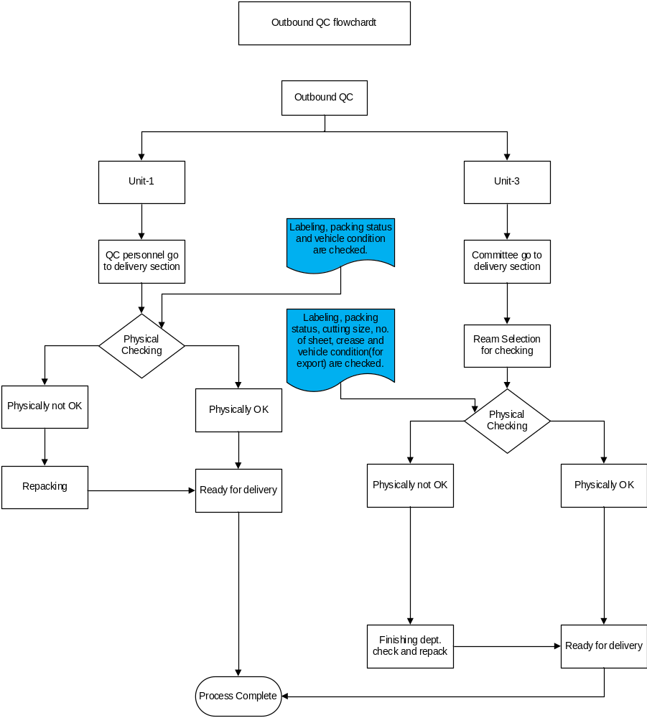

To-BE process of Out Bound inspection Of BPML.

- After receiving the order from the customer, Marketing will prepare the sales order and prepare the delivery document
- An Inspection Lot of type 10 will be created automatically during PGI (if Inspection Type 10 is active in Material master).
- If the material is failing to parameter expectation, then system will generate a notification. However, the stock of the material will be lying in “unrestricted stock” only. After processing the notification and based on the remarks maintained the stock of the material can be moved to “QI” or “Blocked” stock.

NB:
1.In BPML, BBS, Sack plant & PP Woven Bag quality department is different from Paper department. But this universal process is applicable for all.

2. For BPML, UD & stock posting will be executed by Quality Department infect proper mail communication needed from consuming department to accept or Reject process.

MODULE INTEGRATION

Material Management

- Manages quality information for materials, vendors
- Releases vendors; Monitors their QM systems
- Manages the release status of delivery relationships, for example Pre-PPAP, PPAP, Sample Approval etc
- Evaluates vendors on the basis of quality using quality scores from audits, goods receipt inspections, and problem notifications.
- Requests quality certificates and monitors their receipt. Tracking of vendor certificates.
- Triggers inspections for goods movements, for example, goods receipt
- Blocks payments until Inspection Lots are accepted
- Manages the inventory of goods during the inspection and takes the goods being inspected into account for materials planning purposes
- Manages problems using quality notifications and processes complaints against the vendor
- Vendor block/release procedures
- Control of GR Transaction (information/warning/error)

Production Planning

- Batch management
- Handles inspection characteristics and setup characteristics for operations
- Manages quality inspections for manufacturing orders
- Handles in-process inspections during production at freely defined inspection Points- In-process Inspection (Qty/time based)
- Triggers final inspection upon goods receipt from production
- Confirms quality and quantity information for manufacturing orders
- Monitors production quality with the help of control charts and determines process capability scores
- Manages problems in production using quality notifications and by processing corrective tasks

Sales and Distribution

- Customer Complaints Handling
- Manages customer-related quality information
- Triggers an inspection at shipping when the delivery is created- Lot Creation thro PGI for Sales Inspection
- Lot Creation thro PGR for Customer Returns
- Creates quality certificates with the delivery

Plant Maintenance

Equipment related data maintenance as Calibration

Controlling

Cost of Quality

Question and Answer

Gap Analysis

Gap Identified
N/A

Question & Answer

Fit Gap

Reports

Reports and evaluation transaction for Quality Planning

Logistics->QM->QP->Inspection Planning->Information system
QP05 –Print Task List (General)
QP08- Print Task List for material
QP06- Missing or unusable Task Lists (General)
QP07- Missing or unusable Inspection Plans in procurement
QP60-Display Task List Changes
CC04 - Display Product Structure
Logistics->QM->QP->Basic data-> Information system
QS28-Inspection Characteristic List
QS26 - Where Used List- Master Inspection Characteristic
QS38 - Inspection Method List
QS36 - Replace Inspection Method
CR05 - WorkCenter List
QS49 - Code Groups and Codes
QS59 - Selected Sets
QDB3 - Assign Sampling Procedures to Dynamic Modification Rules
Logistics->QM->QP->Logistics Master Data-> Information system
QK02 - QM Orders
QA08 - Inspection Setup
MB56 - Display Batch Where-used List
MB5M - Expiration Date List
COEBR - Batch Record
QI05 - QM Control Key
QI06 - QM Info Record
QV04 - Quality Assurance
QV34 – Technical Delivery Terms

Reports and evaluation transaction for Quality Inspection

Logistics->QM->Quality Inspection-> Info System->Inspection Lot->
Key Figures for Materials / Vendor /Customer/Job Overview
MCXA - Overview of Lots
MCXC - Overview of Quantities
MCXE - Quality Scores
MCXG - Lot Numbers
MCXI – Quantities
MCXK – Work
MCXM - Location/Dispersion
MCVA - Overview of Lots
MCVC - Overview of Quantities
MCVE - Quality Scores
MCVG - Lot Numbers
MCVI - Quantities
MCVK - Work
MCVM - Location/Dispersion
MCOA - Overview of Lots
MCOC - Overview of Quantities
MCOE - Quality Scores
MCOG - Lot Numbers
MCOI – Quantities
MCOK – Work
MCOM - Location/Dispersion
QA33 – List of Inspection Plans
QGA1 - Time Line for Quality Scores
QA06 - Deadline Monitoring of Batches
QA52 - Source Inspection
Logistics->QM->Quality Inspection->Info System->Inspection Result->
Key Figures for Materials / Vendor /Customer
MCXB – General
MCXD – Quantitative
MCVB – General
MCVD – Quantitative
MCOB – General
MCOD – Quantitative
QGP1 - History for Inspection Characteristic
QGA2 – Display
QGA3 – Print
Logistics->QM->Quality Inspection->Info System -> Defects->
MCXX - Key Figures for Material
MCVX - Key Figures for Vendor
MCOX - Key Figures for Customer
Logistics->QM->Quality Inspection->Info System ->Control Chart
QGC1 - For Inspection Lots
QGC2 - For Inspection Characteristic
QGC3 - For Master Inspection Characteristic
Reports and evaluation transaction for Quality certificates
Logistics->QM->Quality Certificates -> Information System
QC55 - Certificate Receipt Worklist
QC20 - Certificates for Deliveries
Reports and evaluation transaction for Quality Notification
Logistics->QM->Quality Notification -> Information System-> Notification/Item
MCXV - Key Figures for Material
MCVZ - Key Figures for Vendor
MCOV - Key Figures for Customer
QM11 – List if Notifications
QM19 - Multi-Level List
QM50 - Time Series Analysis
MCXP - Key Figures for Material
MCVP - Key Figures for Vendor
MCOP - Key Figures for Customer
QM15 – List Notification Items
QM13 - List of Tasks

Reports and evaluation transaction for Test Equipment Management

Logistics->QM->Test Equipment Management-> Information System -> Equipment
IH08 - Display Data
IE07 - Equipment List (Multilevel)
QGP2 - Calibration Results History
QGD1 - Usage History
QGD2 – Tracking
Logistics->QM->Test Equipment Management-> Information System ->Maintenance
IP16 - Display Data
IP14 - Where-Used List
IP24 - Scheduling List
IP19 - Scheduling List as Gantt Diagram
IW40 - Order List (Multilevel)
Logistics->QM->Test Equipment Management-> Information System ->Calibration Inspection
QS26 - Where-Used List for Inspection Characteristic
QS36 - Where-Used List for Inspection Method
QA33 - Inspection Lots
QA32 - Inspection Lots
MCXV - Key Figures for Material
QM11 - Notification List
QM19 - Multi-Level Notification List
QM13 - List of Tasks

User Role and Authorization

Role & Authorization will be fixed further.

Process Improvement

Included in the BBP.

Conclusion

This Blue print on behalf of the Basundhara Paper Mills Quality Management module is developed by so many valuable discussions & getting Inputs from CTM & BPO . I think this blue print is targeting your current practice & process improvement.

